**WEB DESIGN:**

**Designer:** Creates the Look and Feel.

**Developer:** Builds the website based on the design from the designer.

* Front End Developer uses languages such as HTML, CSS and JS for the end which is visible part of the website.
* Popular design right now is **“Flat Design”**

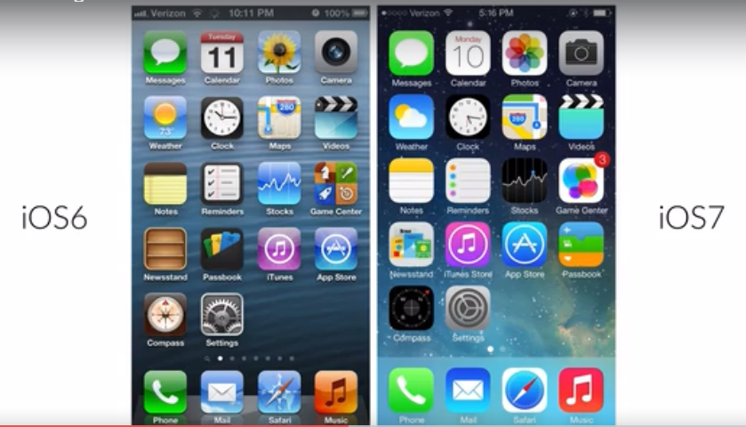

**TYPOGRAPHY:**

***“Typography is the art and technique of arranging type to make written language readable and beautiful”***

Guidelines:

1. Use a font size between 15 and 25px for body text.
2. Use big font sizes for headlines.
3. When you use big font sizes then try to decrease the font weight.
4. Use the line spacing between 120 to 150% of the font size.
5. 45 to 90 characters per line is the optimal line length.
6. Choosing good looking fonts.
7. There are few good fonts they look good in every design

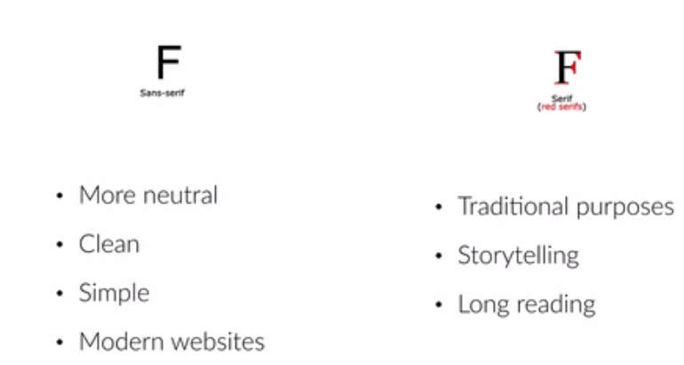

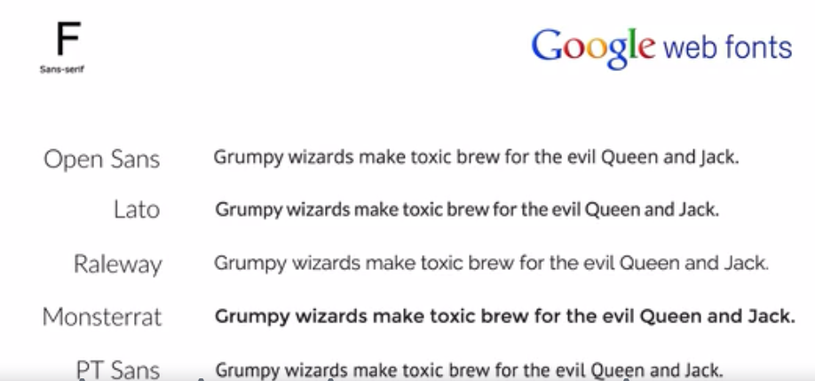

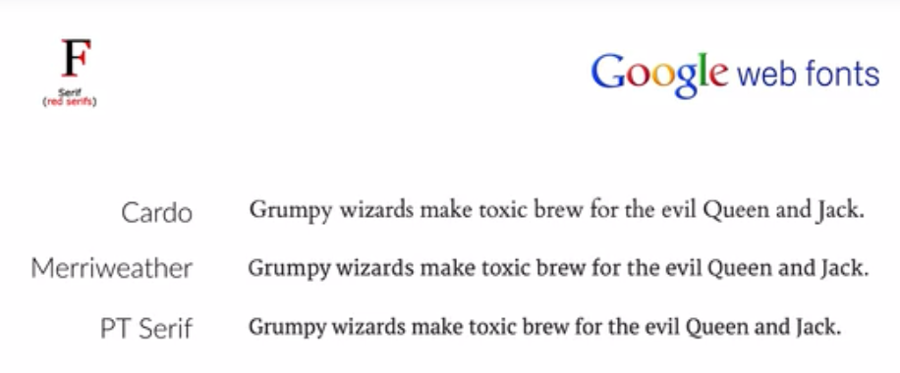

**COLORS:**

1. Use only one base color.

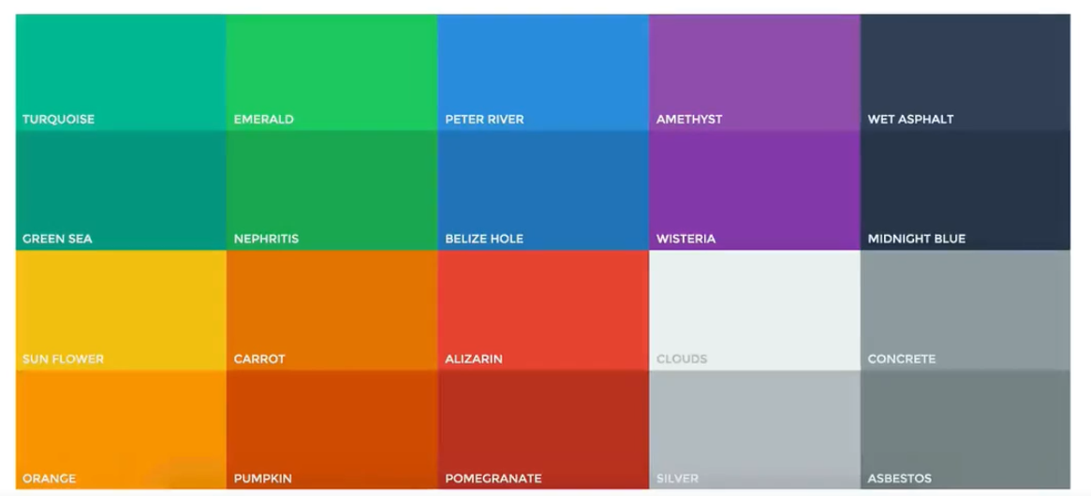

Base color means any color other than black, white and some shade of gray

1. Flat UI color tool is cool tool to choose our base color.
2. Beside choosing the base color we can always choose a darker or lighter version of the same color.

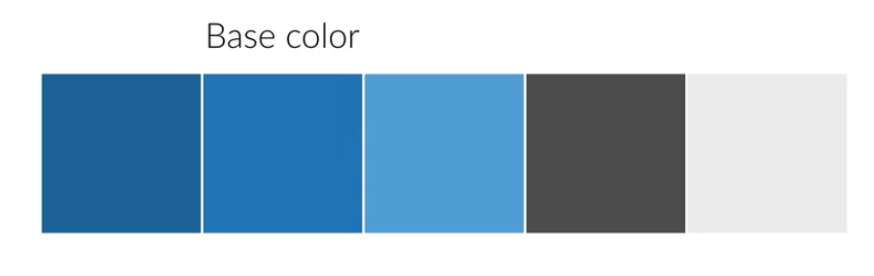

Link: <https://flatuicolors.com/>

1. Never use black as color in our design
2. Choose colors wisely.

Dark shades show more powerful and excitement and lighter shades show excitement

|  |  |
| --- | --- |
| **Color** | **Psychological Behavior or Feelings** |
| Red | Power, passion, strength and excitement to be transmitted |
| Orange | Draws attention without being as overpowering as red – It means cheerfulness and creativity. It can be associated with friendliness, confidence and courage. |
| Yellow | It is energetic and gives the feeling of happiness and liveliness.  It also associated with curiosity, intelligence, brightness etc |
|  | It’s a color of harmony, nature, life and health. Also, it often associated with the money |
|  | It’s a color of patience, peace, trustworthiness and stability (beloved by lots of men). It’s associated with the professionalism, trust and honor.  That’s why all biggest social networks use blue. |
|  | It is traditionally associated with power, nobility and wealth. In our design purple can gives a sense of wisdom, royalty, nobility, luxury and mystery. |
|  | Pink express romance, passivity, care, peace, affection etc. |
|  | It’s a color of relaxation and confidence. Brown itself means earthiness, nature, durability, comfort and reliability |

**IMAGES:**

1. Put text directly on the image (Do not)
2. Overlay the image

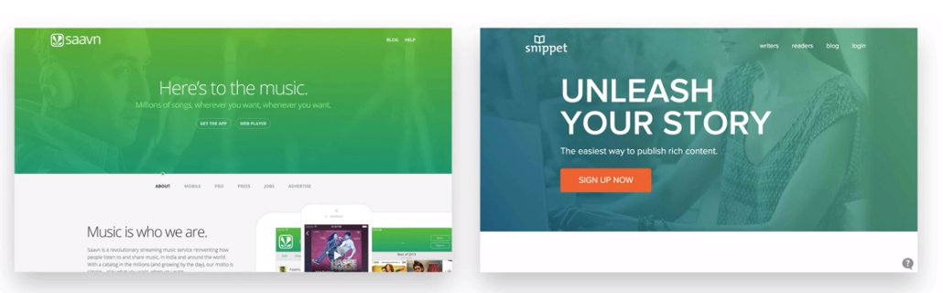

1. Put your text in a box

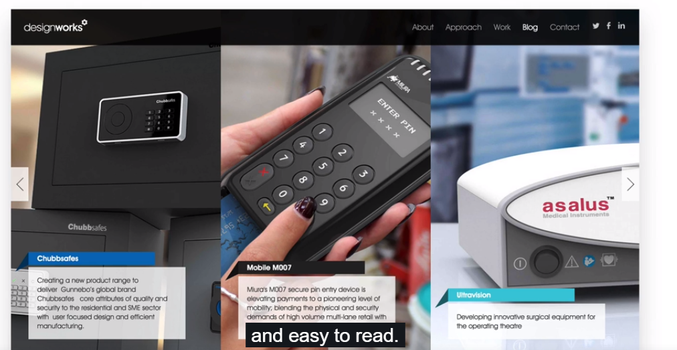

1. Blur the image

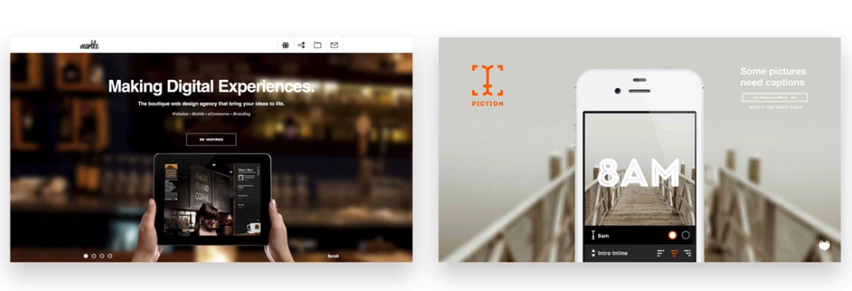

1. Floor fade: It’s a technique where image suddenly fades at the bottom with white text written over it.

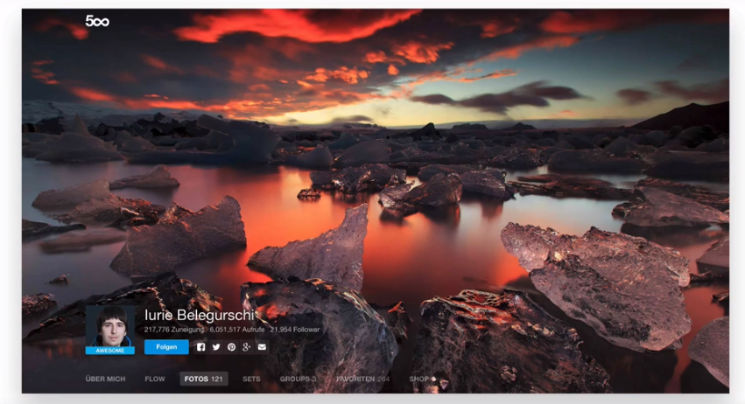

With floor fade

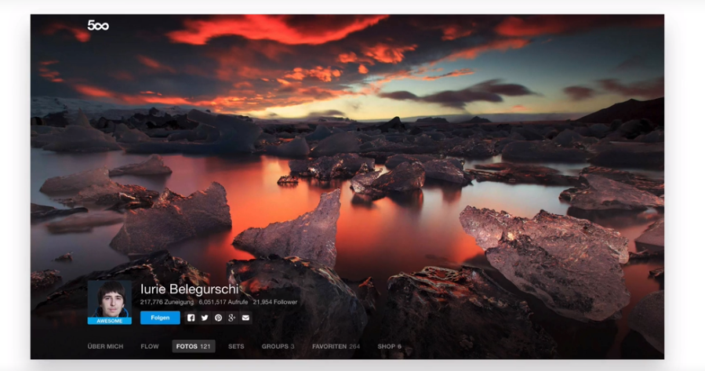

**ICONS:**

* Use icons to list features/steps

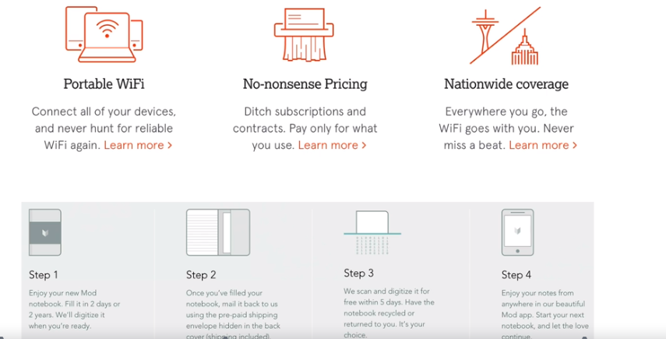

* Use Icons for actions and links

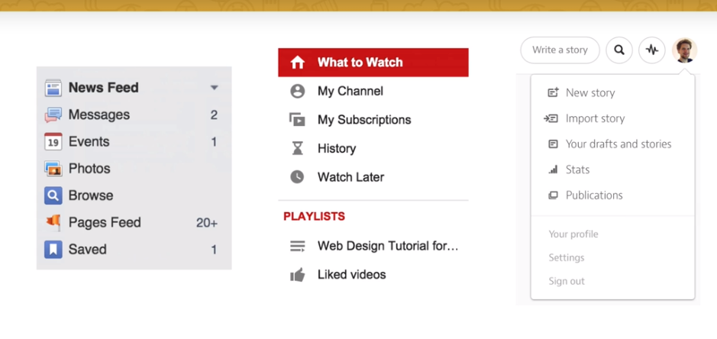

Rules:

1. Icons should be recognizable
2. Label your icons

* Icons should not take center stage of our design

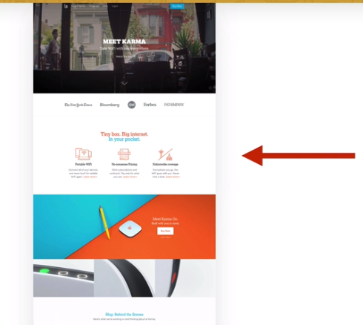

* Use Icon fonts whenever possible

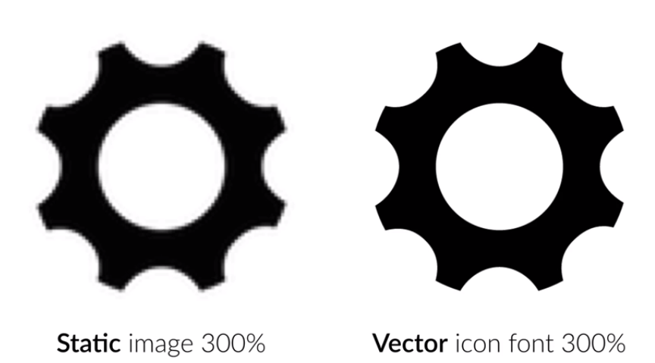

**SPACEING AND LAYOUTS:**

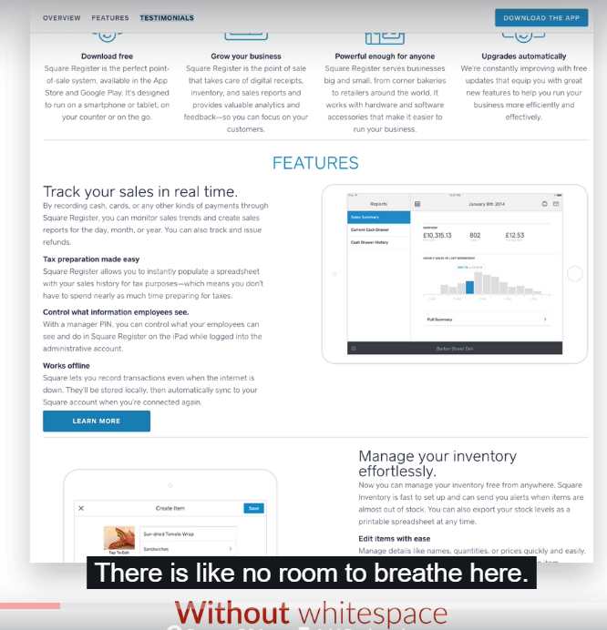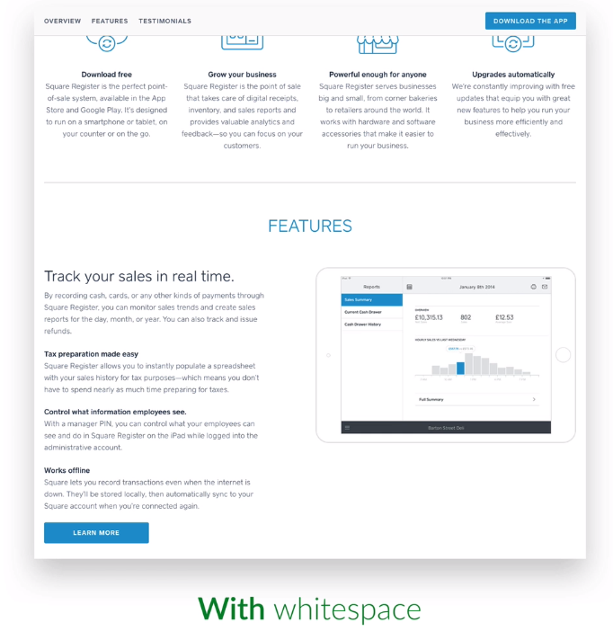

USING WHITESPACE:

* Put whitespace b/w your elements
* Put whitespace b/w your group of elements
* Put whitespace b/w your website’s section
* Don’t exaggerate

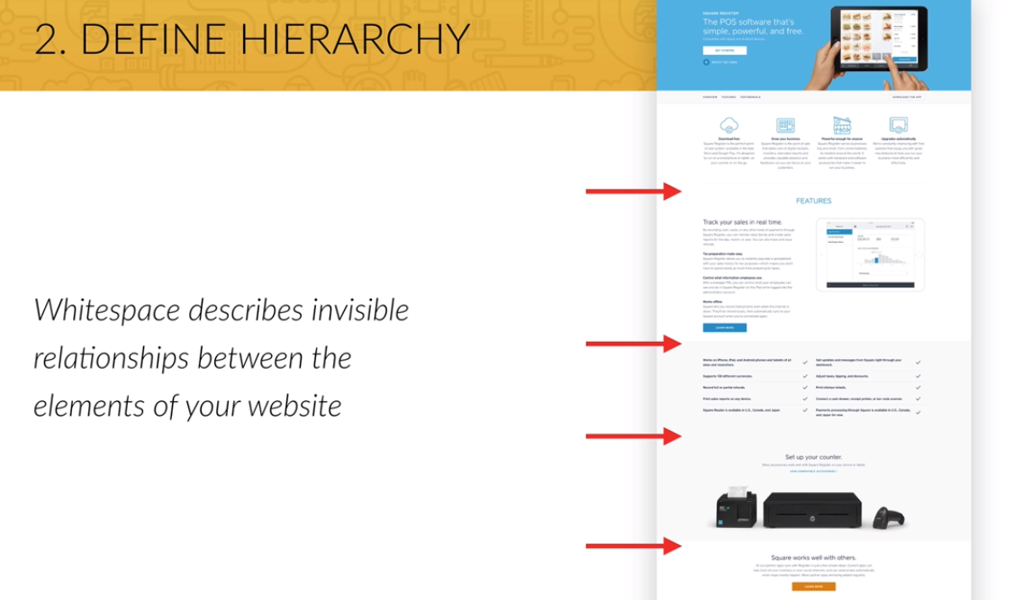

Define Hierarchy:

* Define where you want your audience look first
* Establish a flow that corresponds to your content’s message
* Use whitespace to build that flow.

**Introduction to UX (User Experience):**

**USER INTERFACE** IS THE PERSENTATION OF A PRODUCT HOW IT LOOKS AND FEELS

**USER EXPERIENCE** IS THE OVERALL EXPERIENCE THE USER HAS WITH A PRODUCT

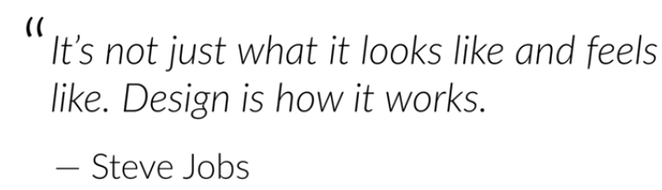

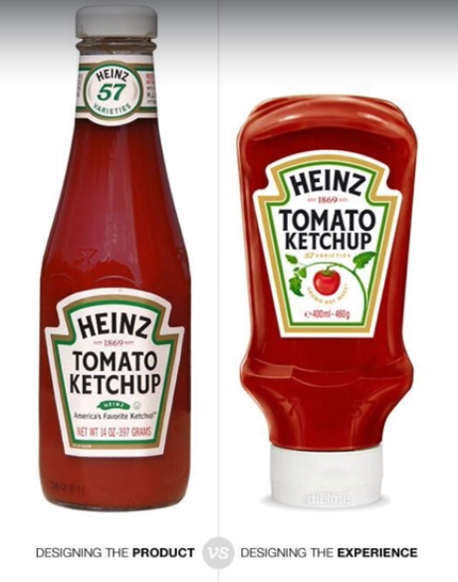

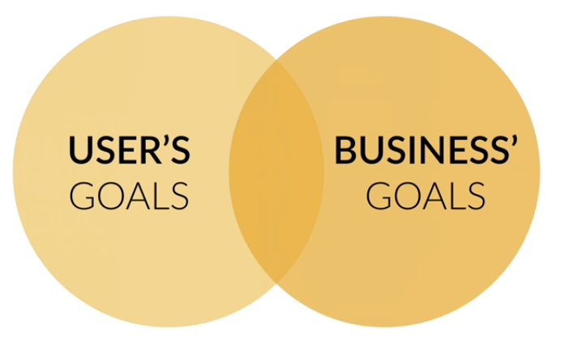

**Getting inspired: Your secret ingredient for stunning web design:**

* Collect design that you like
* Try to understand everything about them
* Why do they look good?
* What do these sites have in common?
* How were they built in HTML and CSS?

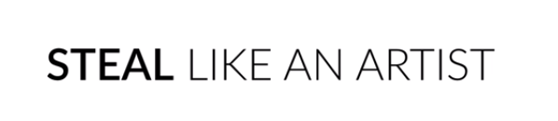

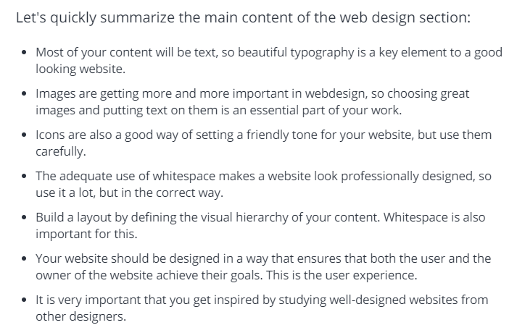

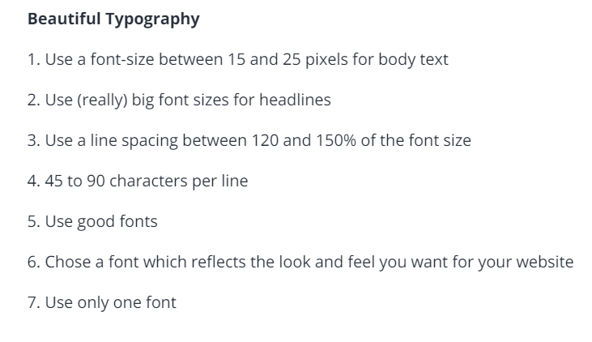

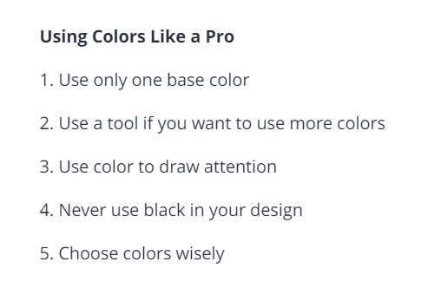

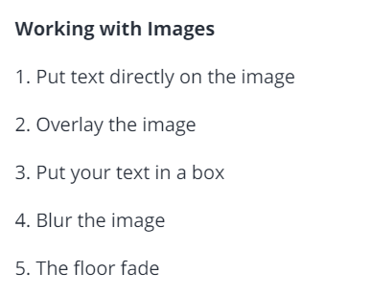

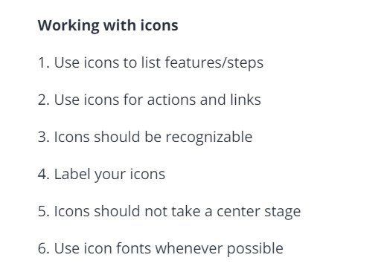

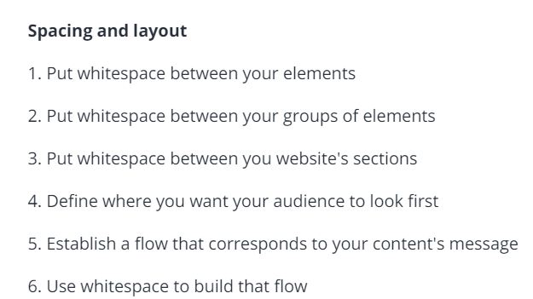

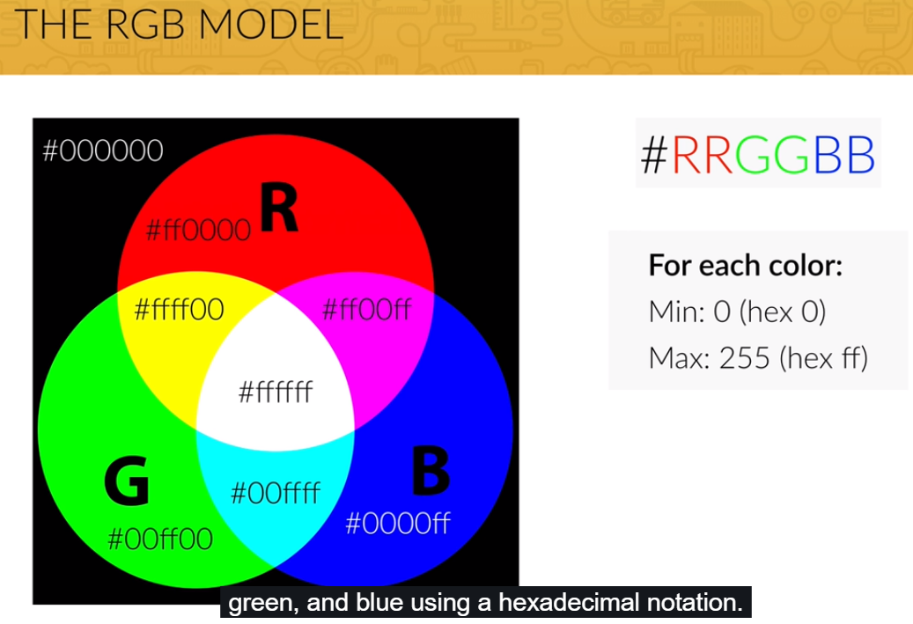

Transparency mentioned in a below way:

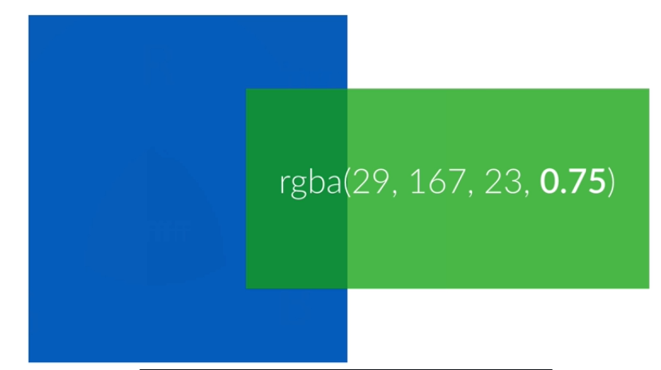

CSS BOX MODEL:

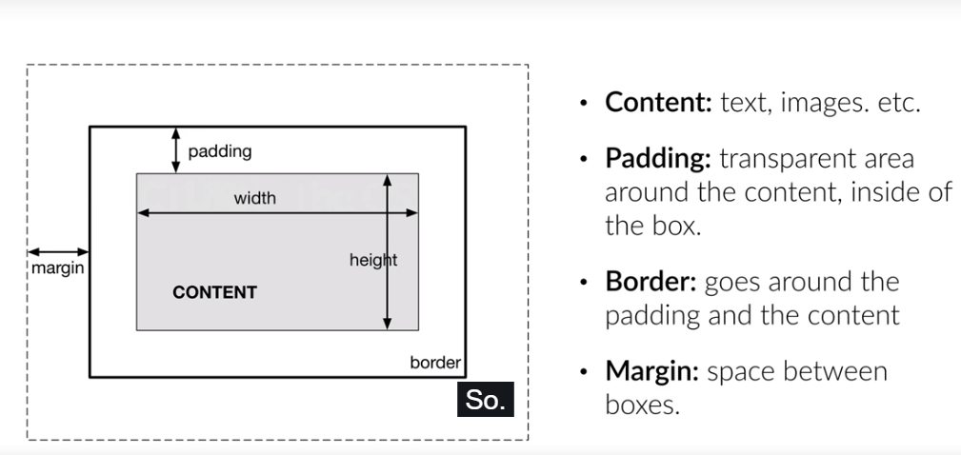

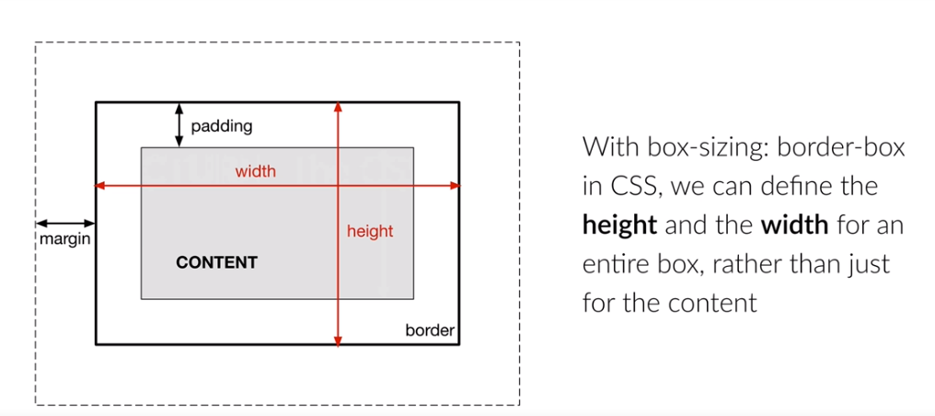

Block Elements: These elements use the full width of the browser and force line breaks.

Ex: h1,h2, p etc.

Inline Elements: Don’t do any of the above which block elements does. But you neither set their height or their width.

Ex: img,a,strong and em etc.

*Elements Positioning:*

* *So far all the elements are relative positioned elements that means that their position on the webpage is determined by the over elements.*
* *Now elements with absolute position can be positioned anywhere we want inside their parent elements*